FOREST OF SOULS 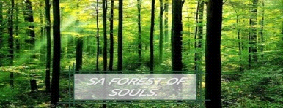
the associates in Christ

21 October 2023 VIRTUAL CELL REPORT
S/N | ITEM | DURATION
1 | Opening Prayer : Pastor Zandile Mogola | 3 Mins
2 | Prayer for our Nation South Africa: Pastor Erlita Mkhwane | 7 Mins
3 | Praise and Worship for Love world singers : Great is the Lord | 6 Mins
4 | ROR Devotional: You Can Cast Out Demons From Anywhere  Minister Lerato Mogola | 5 Mins
5 | Video Playout : Healing Streams Promo: | 5 Mins
6 | Testimonies : Pastor Mandla Sithole | 7 Mins
7 | Bible Study Session : Accelerating Your Growth & Multiplying Your Capacity as a Minister of the Gospel : Cell Leader | 40 Mins
8 | Rounding up the Meeting : Cell Leader encouraging the members about the HSLHS | 7 Mins
9 | Offering = R500 | 5 Mins
10 | Closing Prayer : Pastor Erlita Mkhwane | 5 Mins

CELL LEADER : Pastor Zandile Mogola

